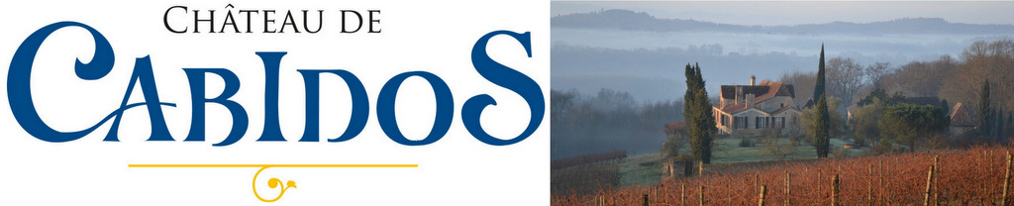

**CABIDOS CUVEE COMTE PHILIPPE**

**IGP Comté Tolosan | South West France**

**PETIT MANSENG SEC**

|  |  |
| --- | --- |
| **Madame Méo Sakorn-Sériès | Maître de Chai and Chef de Culture**  An original and rare wine. The ***COMTE PHILIPPE Petit Manseng Sec*** is made from the estate’s best selection of grapes each year.  **Grape Variety :** 100% Petit Manseng, a low-yielding indigenous variety of South West France.  **Vineyard and viticulture** :   * 7 hectares (17 acres) in a 9 hectare estate created in 1995. * South-facing hillside plantations on stony-clay soils. * Planting density 6,300 vines / hectare with yields of 23-28 hl/ha. * Average age of vines 12-15 years, pruning Guyot Simple. * 100% hand harvesting using cagettes to avoid risk of bruising.   **Vinification and maturation**  A traditional farm-building hides a high-technology winery with temperature-controlled stainless steel tanks, cold settling room and barrel store. A long, cold pre-fermentation settling enhances aroma and flavour development, before fermentation in small lots. The wine is matured for 12 months in 2-3 year old Burgundian oak barrels.  Approx 2-3 g/l residual sugar, 15% abv.  **Tasting note**  Shows wonderfully ripe exotic fruit such as pineapple, and honey on the nose. The palate is well balanced and full bodied, with great acidity, minerality and complexity.  Serve lightly chilled (12-13°C). Wonderful on its own as an autumn aperitif. Also accompanies a wide range of dishes, including Asian and Moroccan cuisine (monkfish tagine) and Italian dishes such as risotto (especially with white truffle or asparagus), tagliatelle with mushrooms, or white meats such as chicken or veal. Works well with Brie and other soft cheeses, and with Tapas. | C:\Users\Alice\Documents\AA WORK\AA CABIDOS\BOTTLESHOTS\Photo bouteille cuvée Comte  Philippe sec médium cropped.jpg |

**AWARDS & REVIEWS**

**Vintage 2011** SILVER : Vignerons Independants

**Vintage 2010** BRONZE : Decanter

**Vintage 2009** GOLD : International Wine Challenge, London **;** SILVER : Decanter World Wine Awards, London

**Vintage 2008** GOLD : Vignerons Indépendants**;**

SILVER : Best French Wines in Asia, Hong Kong; Vigneron Indépendant

**Vintage 2007** GOLD : Decanter World Wine Awards

SILVER : Best Wines in USA, Miami; International Wine Challenge Vienna; Vigneron Independant

**Guide Hachette (the leading French independent wine guide)**

“Coup de Coeur” (editor’s top choice, outstanding wine) for *four consecutive vintages*: 2006, 2007, 2008 and 2009